Web Snap Tool-EZCREATE

Aarthi Sundararajan, Joy Mukherjee and Sanjini Jayaraman

Department of Computer Science
Virginia Tech
Blacksburg, VA 24060
U. S. A.
{aarthi, jmukherj, sanjini } @ vt.edu

ABSTRACT
Information explosion on the World Wide Web has led to a significant growth of databases in terms of size and number. This has a negative impact on the web site designers as this makes the construction and design of the web pages more tedious and time consuming. To enable the web site designers to focus on the content and representation formats of the web pages rather than be overwhelmed by the mass of information, we propose interaction sequences as the solution to the problem. We have developed a tool called EZCreate, which exploits this novel concept of defining interaction sequences for the creation of web pages.

Keywords
Information Visualization, Interaction Sequence, Back-linking, Brushing and linking, User Interface, Pilot study

INTRODUCTION
The World Wide Web has shown explosive growth since its inception. As its popularity surges, so has the information content within it. In short the web can be viewed as a massive global database and the web pages being the external manifestations for this vast amount of data buried within it. Getting the right kind of information on the web pages has always posed a major challenge to web site designers. The information overload aggravates this problem further. This massive amount of information is like a double edged sword – on one hand it enables users to gain access to a wide range of information within a short time but on the other hand makes the task of presenting this information in a form that the user can assimilate easily exceedingly tough. This paper attempts to address this information overload problem primarily from the point of web site designers.

PROBLEM DEFINITION
The advantages of value based services and the nature of the information domain which the web page represents are two major reasons that have fuelled the growth and need for large databases. For example http://www.amazon.com/ is a very large online bookstore, which not only sells but also recommends books. These recommendations are based on the books the user has purchased earlier. Such recommendations are value based services and require large amount of context information to be maintained. Another example is the http://www.ebay.com/ website which sells a variety of commodities ranging from electronic goods to toys. Such sites represent a wide cross section of items on their web pages and the nature of the information domain forces the collection of a large amount of data. So we see that in the present age the size of the database is a natural offshoot. The solution does not lie in tackling the root causes of large databases but by finding a solution which keeps pace with their mushrooming growth.

The impact of this growth weighs heavily on the web site designers. One of the foremost problems that they confront is that they cannot get a good overview of the information that resides in the databases. It is tedious and time consuming for them to open up the databases and get a quick overview of the attributes. Their focus needs to be on the construction of the web site with the essential information that satisfies and appeals to the users. The next major hurdle is that of deciding what to represent on the web pages and how to represent them to create a positive impact on the user. Since the web page designers are presented with a mountain of information, their natural inclination is to present this information as scrollable lists which seems to be the easiest solution to them. Another constraint is that the information needs to be represented on the final web page such that the essence of the data in the database is captured. Hence we have been motivated by the numerous problems faced by the designer and we attempt to present a solution that would mitigate their burden. We focus on web sites in the e-commerce domain in this project.

METHODOLOGY
There are several approaches to constructing web pages. The conventional approach is to use the markup languages like HTML and other tools like using ASP etc. However these approaches don’t solve the problem. Instead they make the process more complicated. An example would make this point more clear. Let us suppose that a designer wants to build a web page for showing the various manufacturers of hard drives, the product names and their details. In creating such a page the designer has to first access the database and retrieve all the hard drive products listed in there. This may require complex queries depending on the organization of data in the database. Then while making the pages, hyper linking across frames, writing code to generate similar pages dynamically, lack of visualization support for presenting the information more effectively and lack of flexibility for incorporating changes make his task extremely cumbersome. From this, one can imagine the amount of hard work involved to construct commercial websites like http://www.ebay.com/, which require building such kind of pages for a wide range of products.

Browsing through a couple of popular web sites revealed that a couple of key relationships exist on any web page. Most pages have a list and a details view, which displays the details of the selected item in the list. We call these connections on the web page as an interaction sequence. Common interaction sequences we identified were list-to-list, list to child list, list to details and list to peer list. By capturing the interaction sequences it would be sufficient for the designer to create the components and specify the connections between them. The interaction sequences cannot be defined at the database level, as it would be very difficult to represent and capture them. The database should be generic enough and such relationships need to be represented at a higher level. Hence we have created a tool, EZCreate that will enable the specification of these sequences at the application level.
LIST

LIST
DB LENS, DB FIRE, DETAILS

DB LENS, DB FIRE, DETAILS
LIST

----…
DB LENS, DB FIRE, DETAILS

Figure 1: Interaction sequences in EZCreate
We have four components in our tool namely the List display, the Details display, DB lens and DB fire. A list can call another list for displaying information. This is a relationship of the kind list to child interaction. The child list can call a DB lens and/or DB fire. This constitutes the list-to-list interaction because essentially the same details in the list are captured for display in either of the tools. From the list or any of the tools a detailed view can be invoked. This forms the list to details interaction sequence. Calling more than one list from a list creates peer child lists and this is the list to peer lists interaction sequence.

Thus the components can be visualized as being connected in a hierarchical fashion. A list forms the root of such a component hierarchy. Selections made in any one of the components results in propagation of the effects to all the components down the hierarchy. The idea is succinctly represented in fig 1.

The various interaction sequences that are supported by our tool are shown in figs 2, 3 and 4.
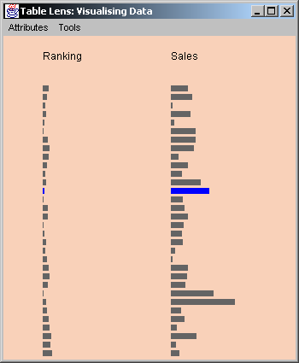
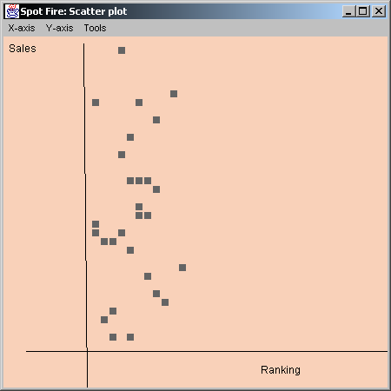
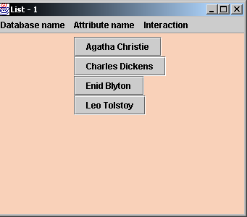

Figure 2: List to List Interaction Sequence

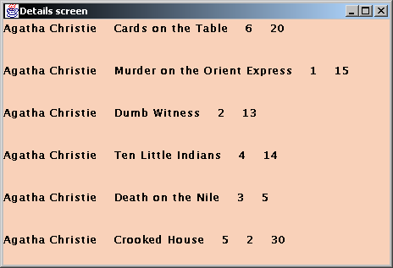
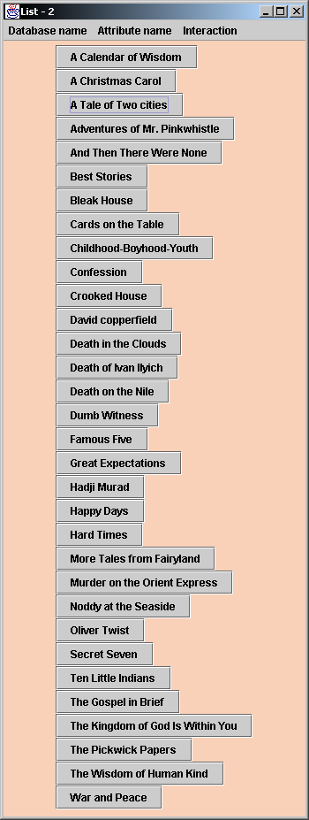

Figure 3: List to Details Interaction Sequence
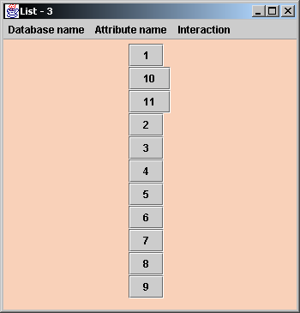

Figure 4: List to Child List Interaction Sequence

FEATURES OF OUR TOOL

The most fundamental feature of the tool is the database overview feature. The designer has to select the database name and the tool shows him the attributes of the data items contained in the corresponding database. Thus the designer can get a good idea of the contents of any database that he has to work with upfront.
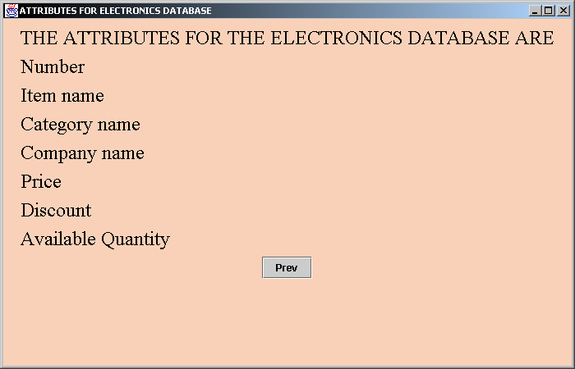

Figure 5: EZCreate-Database Overview Screen

The tool supports four visualization components namely DB lens, DB fire, List display and the Details display and four predefined interaction sequences namely list to list, list to child list, list to details and list to a peer list. These four sequences can be applied to any one of the four visualization components to establish connections between them. Any of the four components can call any of the other four components any number of times. An interaction sequence can therefore consist of many of these components in a sequential order. For example, a list can call another list/DB lens/DB fire/details for information propagation. Currently the tool supports only linear interaction sequences. Screen shots for the DB lens and the DB fire tools are shown below [Figs 6 & 7].
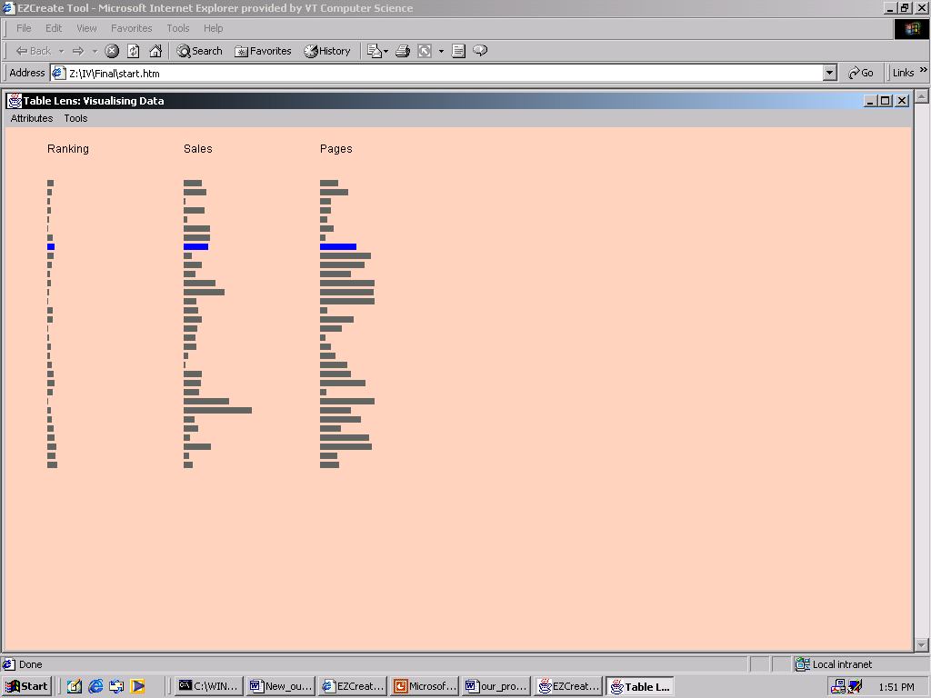

Figure 6: DB lens Tool
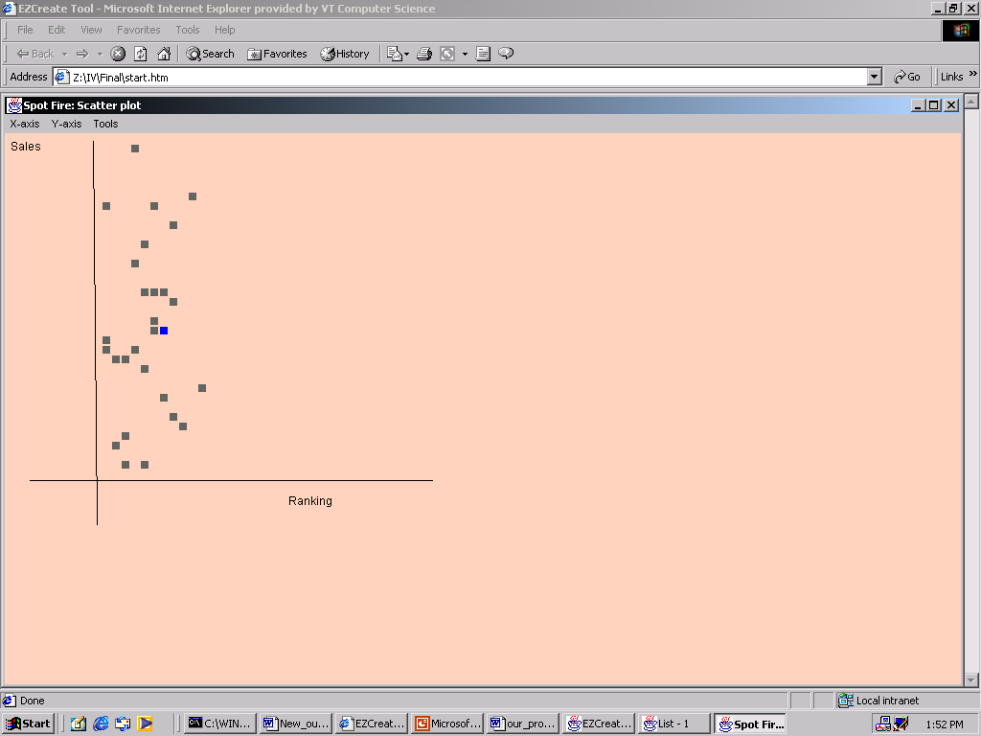

Figure 7: DB fire Tool

The tool also supports two very powerful features namely brushing and linking and back linking in the context of the visualization tools, DB lens and DB fire. Brushing and linking helps in updating the child or peer component based on the selections made by the user in the parent component. Back linking helps the user to highlight a data item in the parent component (DB lens/DB fire) based on the selections made by the user in that component. Thus the users can view and link selected data items between the components in the forward as well as reverse directions.

We have kept the novice user in mind and have provided a help facility. The help consists of short descriptions on how to use the tool to design pages. Finally, the tool has been implemented in Java, which makes it platform independent, and easy to maintain.
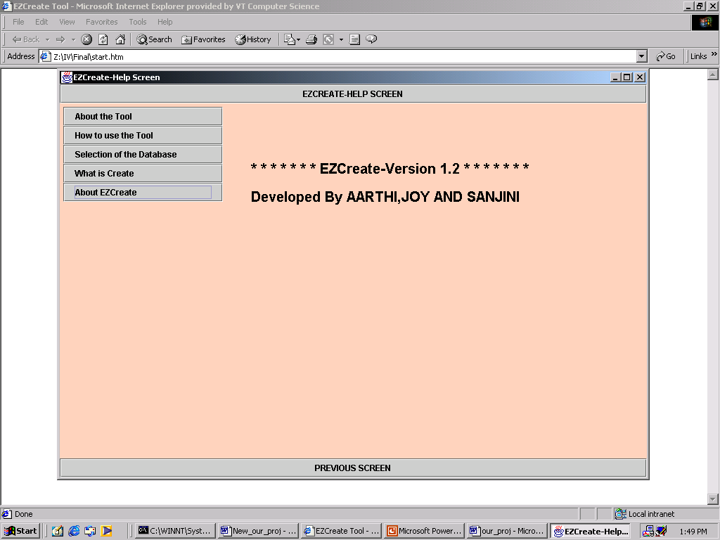

Figure 8: EZCreate Help Screen

Thus the EZCreate tool helps designers to develop individual components of a web page and link them automatically through predefined interaction sequences based on their preferences. These component windows can be embedded in the form of frames on a web page for better organization.

SCENARIOS
A number of interesting web pages can be created easily with the EZCreate tool. We have considered two examples, one in the books database and the other in the electronics database to illustrate our point.

Books database
Consider the case where a website designer would like to create a web page containing the names of the books, their authors, prices and details. The intent of the designer is to enable the users to choose a book very easily and quickly.

The designer first constructs a list displaying the various authors. He then invokes another list from the authors list to display the books written by the particular author. For example if the user had selected Agatha Christie then only the books authored by Agatha Christie are displayed in the child list. This is an example of list to child list interaction. Next the designer intends to display the book prices. An excellent approach is to use visual tools like DB fire to display the rankings and sales of the book. Finally a details list is essential so that the user can have a complete idea of the books that satisfy his criteria. This constitutes an interaction of the type list to details.

On the final web page users can select their favorite authors upon which a list of books by the selected author appears. If the user is interested in any particular book then he can get an idea of its price through the DB fire tool. This visualization gives a comparison of the prices of all the books of a particular author. If the user wants to go for the cheapest option then he may do so. If any item in the plot is selected the details of the book are displayed to the user. The screenshot for the scenario described above is shown in fig.9.
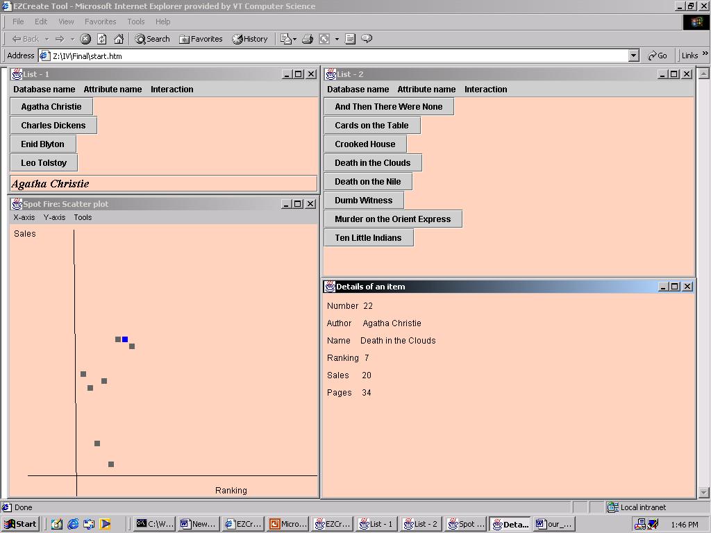

Figure 9: Books database scenario

Electronics database
Let us suppose that the designer desires to develop a web page containing the list of electronic goods for cost conscious customers. The users are just interested in whether there is a discount for the electronic item irrespective of the popularity of the product. The designer conceives a web page browsable by the category of the product and then by the company name in that particular category of goods. He also wants highlight the discount and the price of the products on the final page. So the designer first creates a list, which lists the categories of goods like cameras, calculators and the like. He then creates a child list, which displays the company name and then invokes a DB lens, which displays the price and discount of the commodities manufactured by the corresponding company. The details displayed in the DB lens can be sorted and the details of any item can be seen by means of a details display component along with the DB lens tool. Thus with the help of this page, the user can browse the commodities of a particular company, compare the prices and then select the item with the lowest price for placing the order. The screenshot for the scenario described above is shown in fig.10

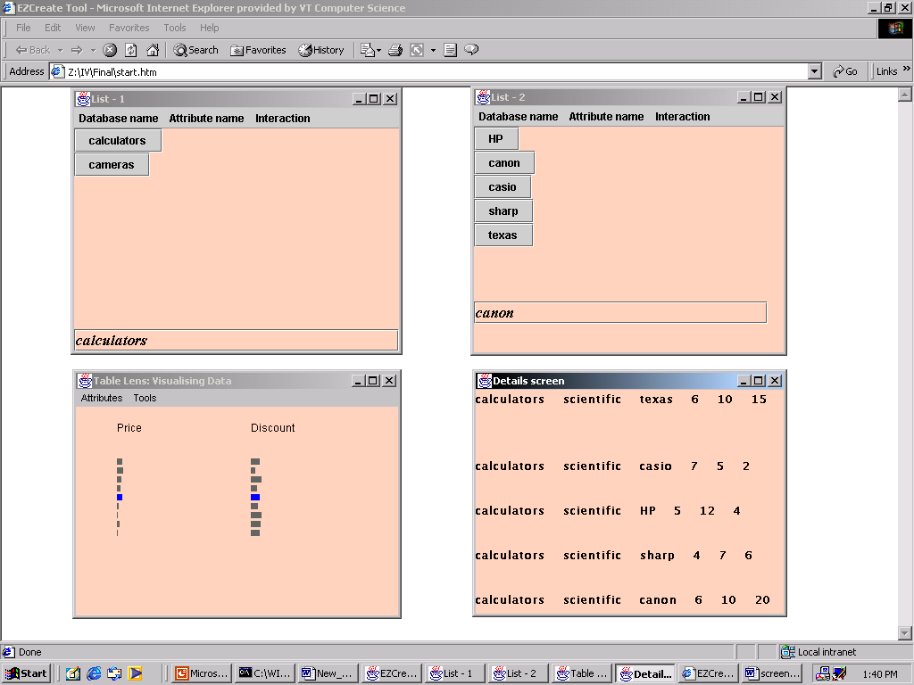

Figure 10: Electronics database scenario

PILOT STUDY AND RESULTS
The main focus of our pilot study is to determine the effectiveness of our tool in performing its intended functions and to determine the general acceptance of this tool by the users. The pilot study that we conducted was thus, a very informal and a casual one. It was done with four participants who were graduate students of the computer science department. They had no knowledge about the Information visualization course and our project. The participants were first given a brief overview of the tool and then were allowed to play with the tool for some time to get accustomed to it. Two of the participants were then asked to use the EZCreate tool from a web page designer’s perspective and the other two participants were asked to use the tool from a casual user’s (who just browses through the web pages for information) perspective. The users who used the tool as a web page designer were asked to establish sequences with the tool for creating web pages that would answer the two user queries “Which are the top rated three books of the author Agatha Christie” and “Find out books that have top rankings as well as sales”. The sequences that were established by these users were then used by the casual users in finding relevant information from the established sequences. The casual users were asked to find answers to the queries that the web page designers used to create the sequences. The users (both the designers and the casual users) were then asked to rate the tool for the following attributes – Ease of Use, User Satisfaction and Learnability. The ratings were on a scale of 1 to 5 where 1 represents a rating corresponding to “poor” and 5 “excellent”. The results of the pilot study are presented in fig.11.

Users/ Attributes | Ease of Use | User Satisfaction | Learnability | Total points
User 1 designer | 4 | 4 | 3 | 11
User 2 designer | 4 | 5 | 4 | 13
User 3 casual user | 5 | 5 | N/A | 10
User 4 casual user | 5 | 5 | N/A | 10

Figure 11: Pilot Study results

The results of the pilot study have made it clear that the designers prefer this tool in comparison to manual creation of web pages. An informal discussion with the casual users after the study also revealed the fact that the users liked the tool to get the desired information rather than browsing through the lengthy, hierarchical web pages to find the desired information.

COMPARISON OF EZCreate WITH EXISTING WEB PAGES
Comparing a page created with the tool with an existing web page (http://www.amazon.com/) can better highlight the advantages of the EZCreate tool. Both the pages contain similar information, which pertains to details of the books of Agatha Christie.

Commercial websites like http://www.amazon.com/ or http://www.ebay.com/ provide information such as the price of the commodities, their rankings, details etc. However the major difference is that this information is presented to the user in the form of a scrollable list, which makes it difficult for them to compare and contrast the details. All the information is thrust on the user through a single page. It is also complex and time consuming to create such scrollable pages. Our approach is different in the sense that designers can create a page with a gradual disclosure of information and with the emphasis on the data items of interest to the user like prices of the products. Users can obtain insight into the idiosyncrasies buried in the presented information through the DB lens or DB fire visualizations, which may influence their purchase decisions. For example a book, which has a low ranking, could have a very high sales value when compared to a book with a comparatively higher rank.

The screens presented below make it explicit that EZCreate presents the same information to the user in an easily navigable and digestible format. Besides the various components such as lists, details etc occupy lesser space providing more room for the addition of more components on the page. The ability to embed visualizations on the page helps in targeting the audience for whom the pages are intended.
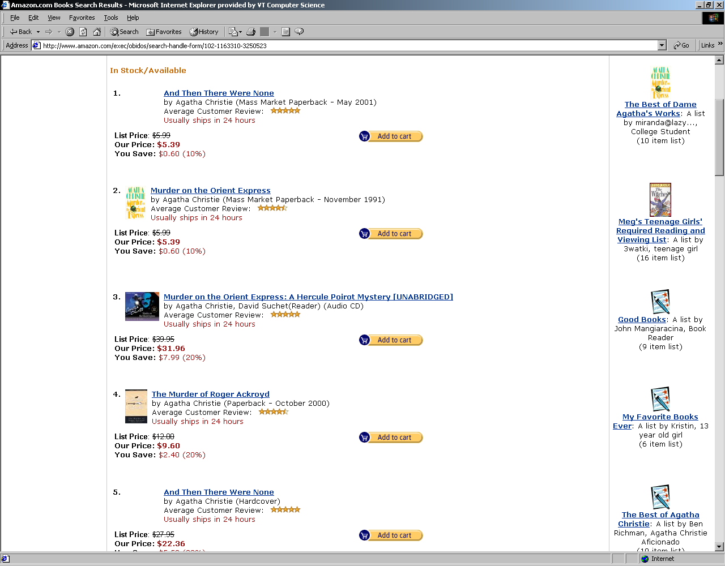

Figure 12: http://www.amazon.com/

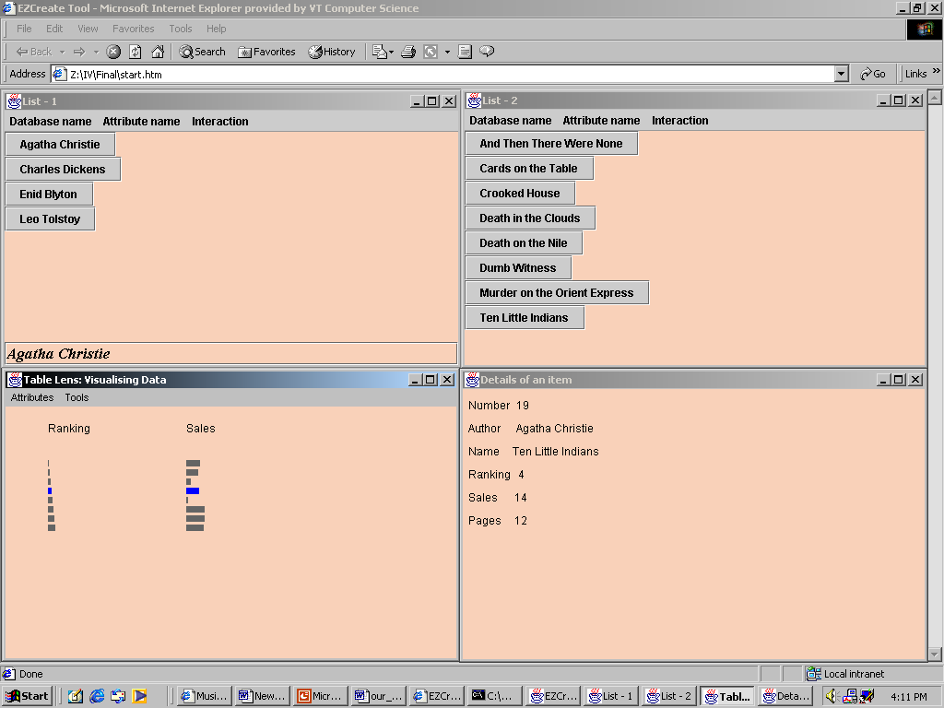

Figure 13: EZCreate Screens for the same content

ADVANTAGES OF THE EZCREATE TOOL
The EZCreate tool, though primarily created with the designers in mind also proved useful to the casual users. The various advantages from the designer’s perspective are:
- The EZCreate does not require the web page designer to write any complex queries. Consequently, the designer need not have an in-depth database querying knowledge.
      - The designer need not be bothered about the information update after the interaction sequence is defined.
      - Lesser effort on the designer’s part in creating similar web-pages.
      - The Visualizations help the designer to decide on the representation formats for the data.

      - The EZCreate tool allows room for creativity.

The various advantages from the user’s perspective are:

- Users can assimilate information very easily.
- Users are better satisfied with this tool when compared to screens containing large amounts of textual data.

CONCLUSIONS AND FUTURE WORK
The web snap concept employing interaction sequences promises a more automated way to designing and linking components to create web pages. Besides incorporating simple visualizations like the DB lens and the DB fire, the tool can make the web pages more powerful in representing the underlying information. This provides a two-fold advantage. Web site designers can concentrate on identifying the necessary visualizations to be displayed on the final web page and link them as desired with ease. Users are also excited about such dynamic pages rather than monotonous scrolling pages. The pilot study conducted at the end of the project reflected the excitement of both the designers and the users revealing that using interaction sequences was a step in the right direction to solving the problem.
However there is more scope for work in this direction. This includes
- Definition of more interaction sequences (both predefined and user defined)
- Display of the final pages on a web page/template
- Incorporation of more visualization tools to visualize the database and represent the information contained in them.
- Provision of Dynamic Query Visualizations [1,2,3] for the database.

ACKNOWLEDGMENTS
We extend our special thanks to Dr. Chris North for his constant help and guidance throughout this project. Our tool is essentially an extension of his Snap-together visualization tool. Thanks are also due to the students of the Information Visualization class for helpful discussions and comments during the course of this project.

REFERENCES
- Snap-Together Visualization: A User Interface for Coordinating Visualizations via Relational Schemata Chris North and Ben Shneiderman
- Doan, K., Plaisant, C., Shneiderman, B. (September 1995) Query previews in networked information systems Proc. of the Third Forum on Research and Technology Advances in Digital Libraries, ADL '96 (Washington, DC, May 13-15, 1996) IEEE CS Press, 120-129.
- Ahlberg, C., Wistrand, E., "IVEE: An Information", Proc. IEEE Information Visualization '95, pp. 66-73, (1995).
- Livny, M., Ramakrishnan, R., Beyer, K., Chen G., Donjerkovic, D., Lawande, S., Myllymaki, J., Wenger, K., "DEVise: integrated querying and visual exploration of large datasets", Proc. ACM SIGMOD'97, pp. 301-312, (1997).
- R. Rao, S. Card, "The Table lens: Merging graphical and symbolic representations in an interactive focus + context visualization for tabular information", Proceedings of ACM CHI'94, pages 318--482, 1994.
7. Richard Chimera, Ben Shneiderman, "Spot fire-An Exploratory Evaluation of Three Interfaces for Browsing Large Hierarchical Tables of Contents", Information Systems, volume12, number 4, pages 383-406,1994,

