Visual Computing Group
of Virginia Tech

Across domains, researchers, engineers, and designers are faced with large volumes of data that are heterogeneous in nature. While computers can provide excellent memory and computational prostheses for solving complex problems, they are unable to match the human’s abilities for pattern-recognition, creative reasoning, and insight. It is imperative that next-generation interfaces leverage the strengths of the human operator to create useful and economical tools for analysis and decision-making. In order to investigate and communicate complex phenomenon in science and education, Visual Computing is essential
“Visual computing is computing that lets you interact with and control work by manipulating visual images either as direct work objects or as objects representing other objects that are not necessarily visual themselves” (whatIs.com). Visual Computing tools facilitate analytical reasoning on large heterogeneous data sets through interactive visual interfaces. Visual Computing tools include graphical user interfaces, virtual environments, information visualization, and augmented reality. Such tools are also known as ‘visual analytics’ tools and complement data-mining and statistical as well as High-Performance Computing systems such as simulation and numeric computation.
Visual computing research activities include visualization, computer graphics, image processing, medical imaging, virtual reality, user interfaces, computer-supported collaborative work, computer-aided design, multimedia, and computational geometry, as well as numerous applications of these areas. The Visual Computing Group of Virginia Tech will provide the dedicated staff and infrastructure support required to fully realize the potential of visual tools for computational science and education at Virginia Tech.
The group represents an important element of advancing VT leadership in research and education through visual communication. Through faculty and graduate education and development support, VT will enable more productive scientists and more competitive researchers. In addition, the proposed plan will proliferate visual computing solutions around colleges and classrooms. The Visual Computing Group will anchor VT’s efforts in establishing visual computing as a core competency and world-class resource.

Northern Capitol Region
A crucial component in the success of VT’s Northern Capitol Region (NCR) presence is visual computing and communication. The top national agencies, labs, and universities recognize the importance of visualization support for scientists through their hardware and software infrastructure and application development. In order to be competitive in this space, VT must make a commitment to build this program and enable the community with cutting-edge capabilities and expertise.
By building up the Visual Computing program at the main campus, VT will be well-positioned to present its best and brightest to the NRC. For example with infrastructure, staff, and tools in place on the main campus, VT scientists and educators will be enabled with visual tools for analysis, insight and communication. This will be especially beneficial for visual presentations of their research results on big science problems to funding agencies and industry. In addition, these tools can be the basis for workshops and training sessions held for local industry.

Complex Systems
In many systems, dynamic properties are best modeled with their spatial and structural aspects - spatial relationships are important when structure, location, and function are related. Indeed, this is the case in many domains where complex systems are designed, simulated, or analyzed. Visual Computing seeks to reduce the cognitive distance between the user and the system and increase the information throughput between the user and the system.
Through interactive graphical representations, Visual Computing tools can provide user control of overview and detail views, heterogeneous datasets, and simulation parameters. There are a number of current research projects at VT using visualization in this way and these are shown in the following page. While each of these projects demonstrates the value of visual tools to complex systems research, there are many aspects that must be improved and expanded.

Strategic Plan
The 21st Century has opened up a new paradigm for science and research. With the increase in affordable technology, the Computational Sciences are contributing more and more to our understanding of the world around us. Virginia Tech is consistently a leader in innovation and nationally ranked as a research institution; but there is always room for improvement. This document outlines a proposal to unify our fragmented resources and position VT at the forefront of the modern research enterprise.
Through the Offices of Research Computing and Information Technology, this Visual Computing Group will provide the dedicated staff and infrastructure support required to fully realize the potential of visual tools for computational science and education at Virginia Tech. This group will expand the existing federally and university-funded infrastructures and allocate resources as follows:
- 60 % research application support
- 30 % education application support
- 10 % outreach support
The Director of Visual Computing will sit on 2 boards related to the management of visualization resources, which include:
- The Advisory Board which meets monthly to review data, policies, and procedures. This group, which will be made up of VT personnel, will also recommend hardware and software upgrades, and publicity activities.
- The Stakeholders Group comprised of VTIT/Research Computing, Research Division, and representatives from each active College, Center, Institute, or Department. This board will meet semi-annually for review of data, procedures and policies.
Visual Computing Group Mission:
- Education, outreach, and consulting to faculty and researchers regarding the value of Visualization and HPC for their research (e.g. workshops & colloquia)
- Provide expert staff to :
  - Consult with researchers and educators about applications of HPC and visualization technology
  - Develop visualization tools and collaborative infrastructure for domain experts / HPC users
  - Develop additional grants and funding streams with domain experts to include visualization tools and HPC
- Continue a robust research program in HCI and information architectures
- Provide ‘World-Class’ visualization facilities for university researchers and faculty
Initially, the group will work with the VT’s user base of computational scientists to devise and deliver solutions for scientific visual analysis. This effort will lead to a number of grant proposals to fund Post-docs who will continue to develop domain-specific applications. The CAVE will continue to serve as the flagship immersive venue on campus. The deployment of stereo walls around campus will increase faculty and student access to these visualization tools and computing resources. The group will collaborate with CS and CHCI to design and evaluate these initial projects.
In the interest of connecting desktops, the CAVE, satellite sites, and HPC resources, the group will continue to the development of open-source solutions for information management, delivery, and visualization. This includes informatics gateways and lab management software as well as visualization components and web services for individual or collaborative use. The group will actively participate in International Standards (e.g. ISO, Web3D, W3C) development for networked 3D graphics and visualization systems, further establishing VT as a leader in visual computing technology. As the hardware and software technology infrastructure is established, the staff will be expanded to serve more researchers, departments, and projects.

Examples of Visual Computing in VT Complex Systems Research

Cellular signaling & Molecular Dynamics
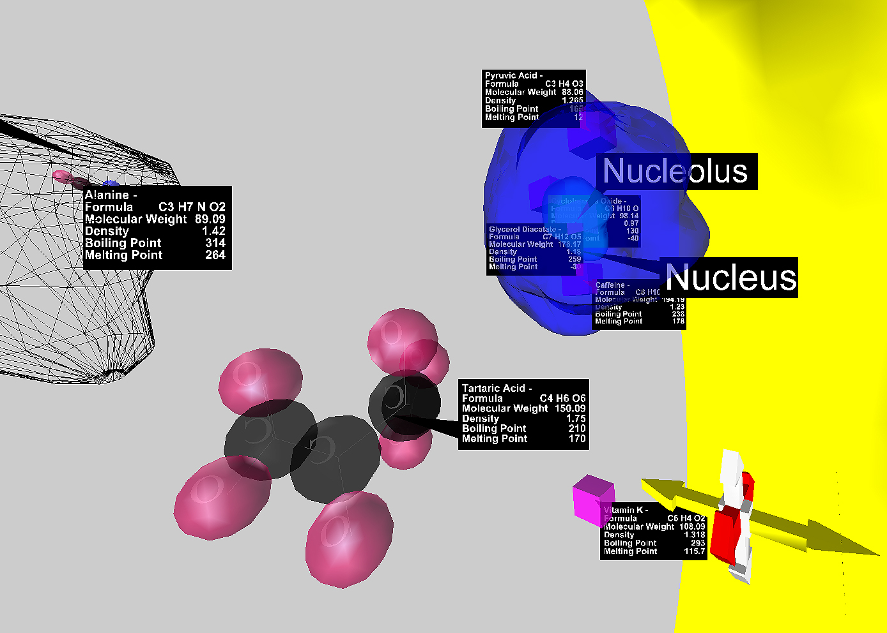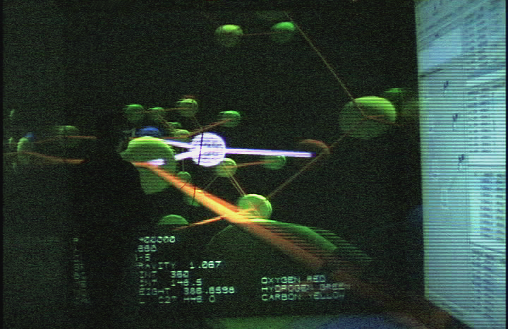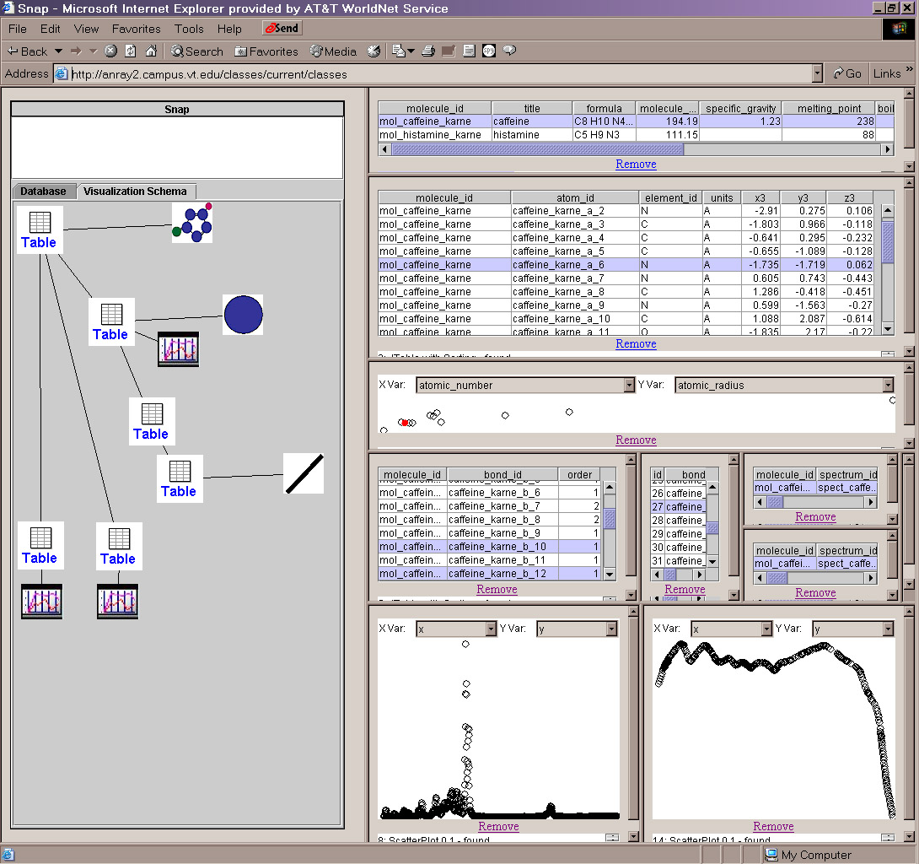
Immunology / Virology (PathSim)
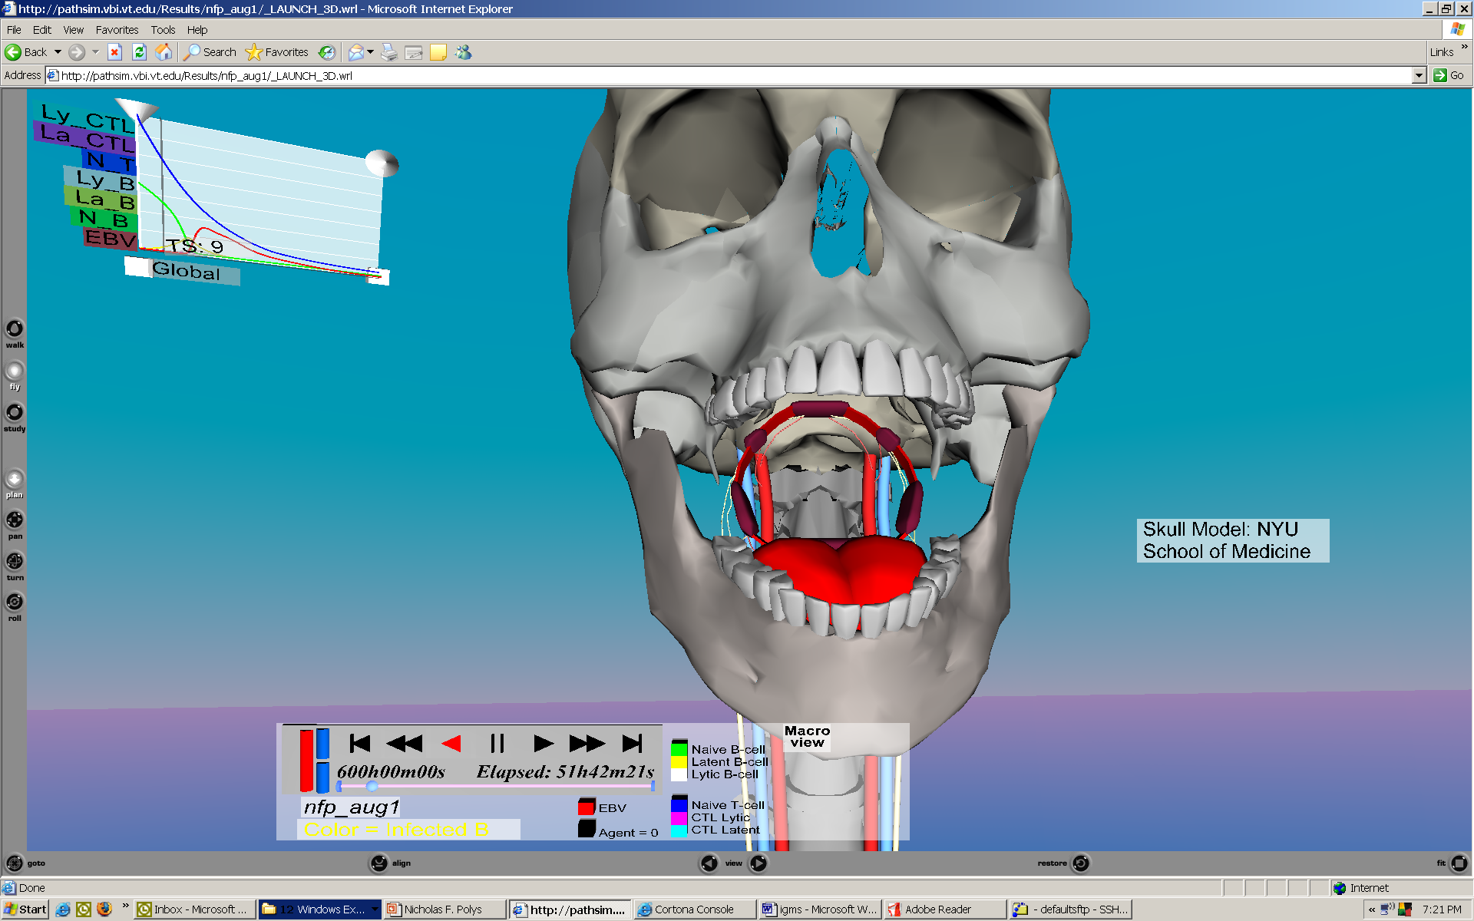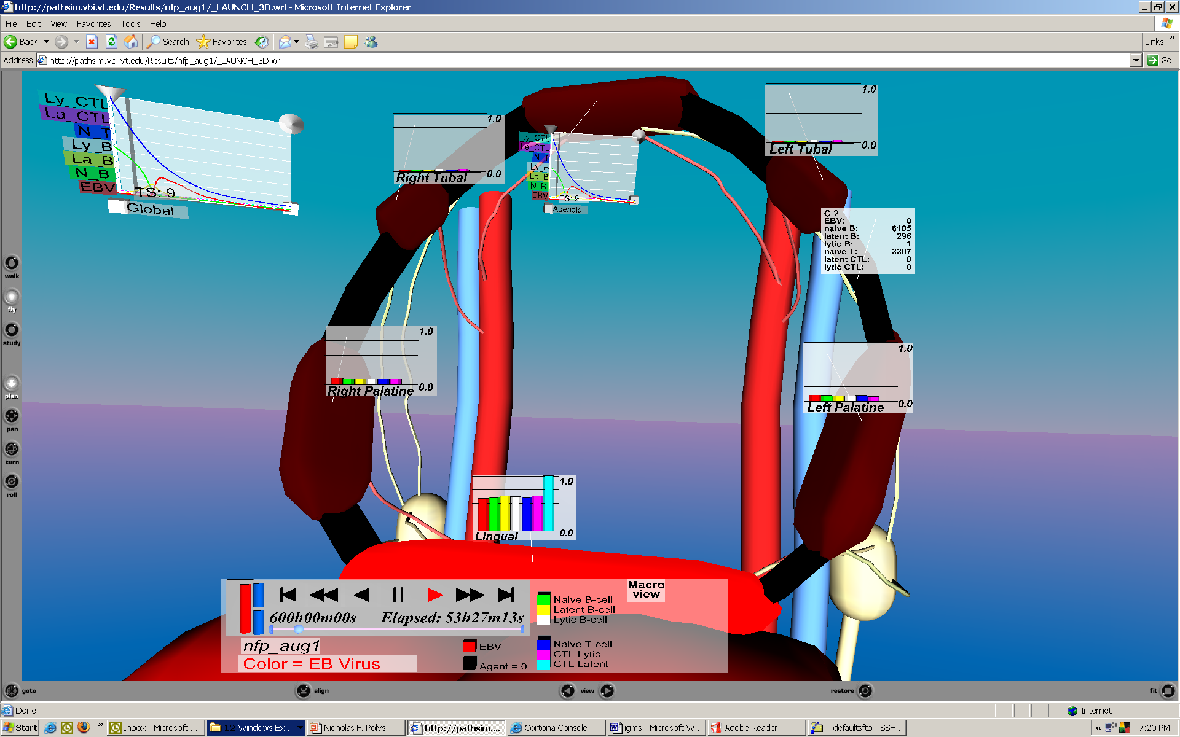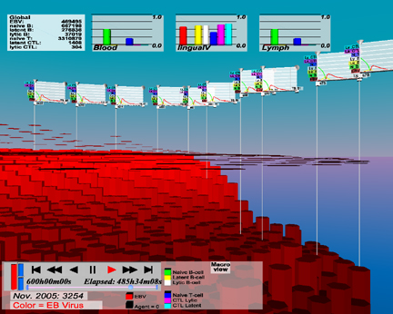
Epidemiology, Disaster Mitigation, & Social Networks (EpiSims)
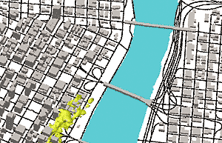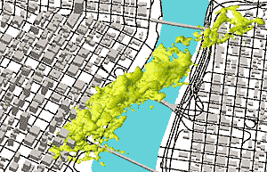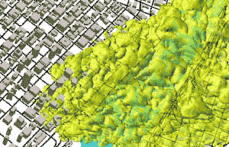
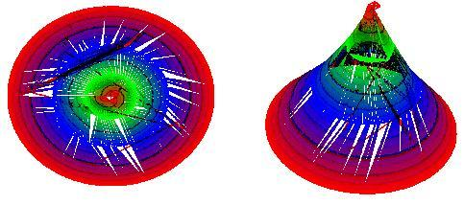
Transportation (Transims)
