Seminar Announcement Virginia Tech National Capital Region
Oct. 13, 2006, Friday at 2 PM-3PM
Department of Computer Science Conference Room
7054 Haycock Road, Falls Church, VA 22043
Contact: ctlu@vt.edu Phone: (703) 538-8373
Title: Virtual Hospital from tanks to tumors 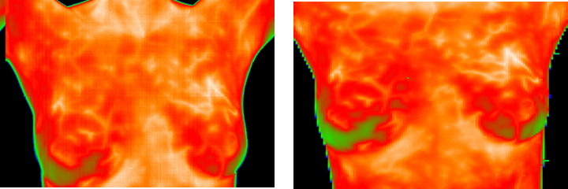
Speaker: Dr. Harold Szu, Fellows of IEEE and AIMBE
ONR Program Officer code 312 Sensors, Surveillance, Communication
Director, Digital Media RF Lab, & Research Professor of GWU

Abstract: Hospitals world-wide are facing bed-limiting challenging for taking care of aging baby-boomers’ sickness. We address a virtual “Hauspital” remedy. Three unique enablers are given. (i) Progress of truly unsupervised learning neural networks will be derived from the first biophysics principle, and applied to the real world remote sensing as well as an early breast cancer diagnosis. Unsupervised feature extraction and unbiased fusion are based on a passive pair of dual color infrared cameras and a generalized Shannon information theory in open dynamical systems, based on a local isothermal equilibrium such as the mother earth and the mother breast. Then, (ii) affordable diagnostic instrumentations at household will be based on the over-sampling redundancy reduction super-resolution methodology. Lastly, (iii) we introduce a powerful concept of how to benchmark the household diagnostics by producing an equivalent ROC performance metric in a time reversal fashion, as it was suggested by Cardinal Ruhini and the Saint John Paul Pope, in exchanging Vatican PLU Hospital data with Navy patent license right.
Biography: 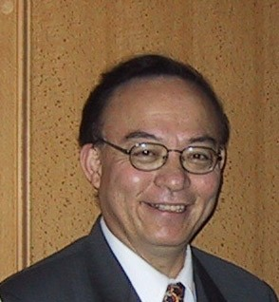 Dr. Harold Szu received his Ph D from the Rockefeller University in 1971, and worked at Naval Research Laboratory, NSWC and ONR over three decades. He is a founder of International Neural Network Society in 1988, and elected to be Fellows of several professional societies, SPIE 1994, OSA 1995, IEEE 1996, AIMBE 2004, and received the Academician of Russian Academy of Nonlinear Sciences in 1999 for his contribution to fast Cauchy simulated annealing, chaos fuzzy, adaptive wavelets, and the supervised learning respectively. He has published three hundreds papers, dozen patents, and received numerous honors and awards. Furthermore, he has always involved university education, UNC Chapel Hill, UCLA Short Courses, AU Resident Prof, UL Lafayette: Lamson endowed Prof, GWU: Res. Frof, and trained a dozen of Ph D students under the so-called Royal Dutch Creativity Tradition of Prof. George Eugene Uhlenbeck.

